
Lab Report 01
Data Communication & Computer Networks


Submitted To:
Engineer Shehzad Malik
Submitted By:
Sumama Rahim
F24BSCS039
BS CS (F24-Morning)
Date: 10/14/2025
LAB REPORT – 01
Cisco Packet Tracer – Basic Commands

Task 1:
How to check details of router?
Solution:
Steps
- Go to enable mode
- show running-config
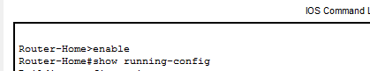

Output
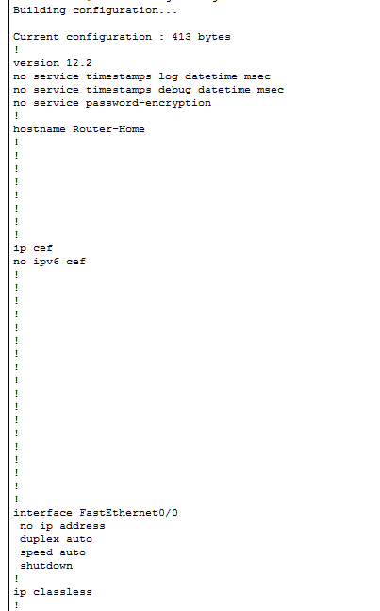

Task 2:
How to change host name?
Solution:
Steps
- Go to enable mode
- Configure terminal
- Hostname newName
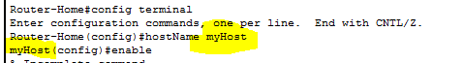

Task 3:
How to set date and time?
Solution:
Steps
- Show clock
- Go to enable mode
- Clock set HH:MM: SS DD MM/Mon YYYY
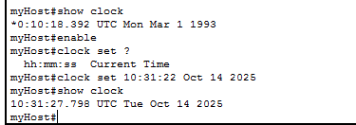

Task 4:
How to set Line Console Password?
Solution:
Steps
- Go to enable mode
- Configure terminal
- Line console 0
- Password PASSWORD
NOTE: Remeber this will not work, so we need some fixings
- Login and hit enter
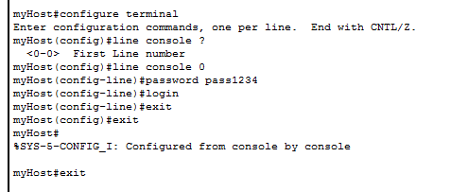
Output
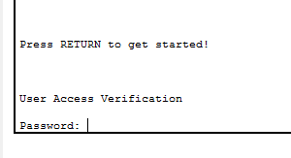

Task 5:
How to set password at privileged/Enable mode
Solution:
Steps
- Go to enable mode
- Configure terminal
- Enable password PASSWORD
NOTE: This password will require whenever visiting enable
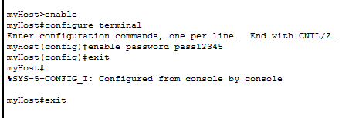
Output
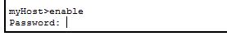
To check for changes, enable -> show running-config
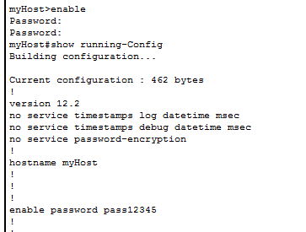
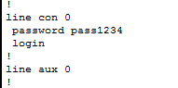

Task 6:
How to set secret password at privileged/Enable mode
Solution:
Steps
- Go to enable mode
- Configure terminal
- enable secret PASSWORD
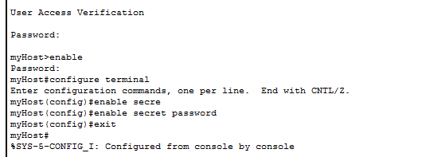

To check, enable > show running-config
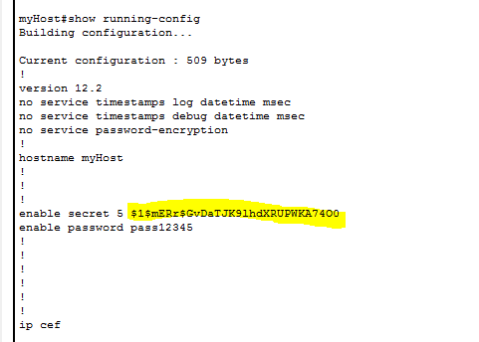

Task 7:
How to remove password at privileged/Enable mode
Solution:
Steps
- Go to enable mode
- Configure terminal
- No enable password

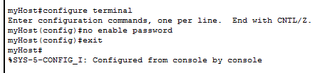

To check, enable > show running-config

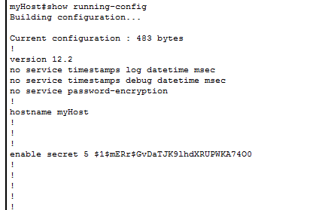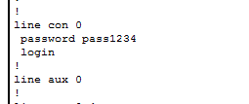

Task 8:
How to remove password at Line console?
Solution:
Steps
- Go to enable mode
- Configure terminal
- Line console 0
- No password
- No login

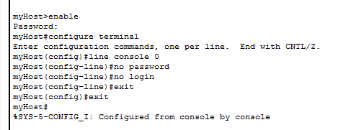

To check, enable > show running-config

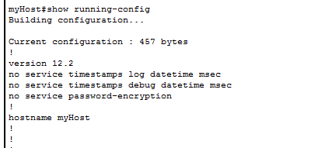

Task 9:
How to remove secret password at privileged/Enable mode?
Solution:
Steps
- Go to enable mode
- Configure terminal
- No enable secret
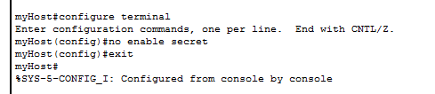

To check, enable > show running-config

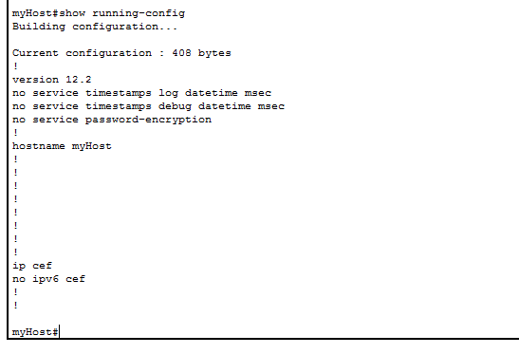

Task 10:
How to check version and other details?
Solution:
Steps
- Go to enable mode
- Show version

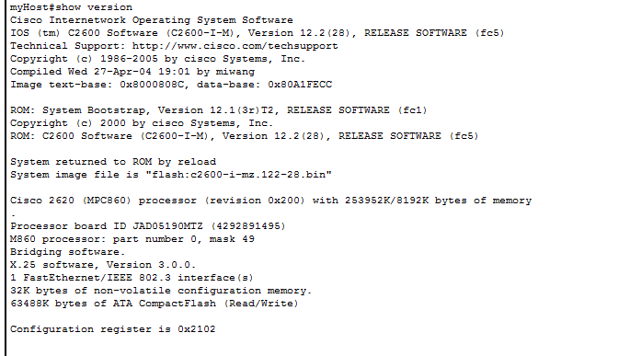

To check, enable > show running-config

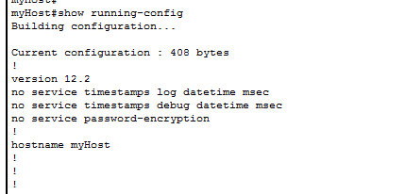

The End

